**AI-ENHANCED PERSONALIZED LEARNING SUPPORT SYSTEM**

**ABSTRACT**

The need for continuous skill acquisition in a fast-paced, technology-driven world has exposed the limitations of existing e-learning platforms. Despite offering vast resources, platforms like Coursera and Udemy often rely on static, one-size-fits-all learning paths that fail to address individual needs. Learners struggle with balancing the mastery of current skills while pursuing new ones, leading to inefficiencies and skill decay. This paper presents an AI-Enhanced Personalized Learning Support System, an innovative solution that transforms the learning experience through dynamic, adaptive, and personalized strategies. The system leverages AI to create tailored learning pathways, generate adaptive quizzes, and provide real-time feedback on language and writing proficiency. A comprehensive dashboard enables mentors and organizations to track progress, identify gaps, and facilitate targeted interventions. By incorporating collaborative tools like community forums and real-time communication features, the platform also fosters peer-to-peer learning and knowledge exchange. Designed to empower individuals and institutions alike, this system redefines personalized education by ensuring learners remain on track toward their goals while adapting to the ever-changing demands of the modern world.

**KEYWORDS**

Personalized Learning , Artificial Intelligence (AI), Adaptive Assessments, Skill Tracking, Skill Maintenance ,Dynamic Learning Pathways , AI in Education , E-Learning Platforms, AI-Generated Quizzes , Lifelong Learning , Recommendation Systems , Collaborative Learning, Community Engagement

**INTRODUCTION**

In the era of rapid technological advancements, the demand for acquiring and mastering new skills has become paramount for both individuals and organizations. Online learning platforms such as Coursera, Udemy, and edX have revolutionized access to education, offering learners a wealth of resources across various domains. However, these platforms often rely on static, interest-based recommendations that fail to account for the unique strengths, weaknesses, and evolving goals of individual learners. This mismatch leads to inefficient learning, with users revisiting familiar topics or struggling to retain existing skills while exploring new ones.

Traditional e-learning platforms fall short in providing personalized guidance. They offer generic pathways that lack adaptability to changing learner needs. This one-size-fits-all approach does not align with the diversity in learning paces, skill levels, or career aspirations of users. Additionally, learners often struggle with skill decay, where infrequent usage of acquired knowledge leads to a gradual decline in proficiency. Addressing these challenges necessitates an innovative, dynamic, and tailored approach to education.

Artificial Intelligence (AI) has emerged as a transformative force across industries, including healthcare, finance, manufacturing, and entertainment. Its application in education, however, remains underutilized. By harnessing the power of AI, personalized learning systems can overcome the limitations of traditional platforms. These systems can dynamically adapt to learners' progress, generate custom recommendations, and provide continuous support to ensure effective skill acquisition and retention.

This paper introduces an AI-Enhanced Personalized Learning Support System designed to redefine the e-learning experience. The proposed platform provides customized learning pathways tailored to individual needs, AI-generated quizzes for dynamic skill assessment, and real-time assistance for language and writing skills. It empowers mentors and organizations with tools to monitor learner progress and foster collaborative learning through community features. The system not only addresses existing gaps but also ensures learners stay aligned with their goals in a structured, efficient, and engaging manner.  
  
**Literature Review**

The increasing demand for personalized and effective learning experiences has driven significant research in the fields of educational technology and artificial intelligence (AI). As educational systems seek to optimize learning for diverse student populations, understanding how technology can enhance learning experiences is paramount. This literature review examines existing work related to personalized learning systems, adaptive learning technologies, recommendation systems in education, skill maintenance strategies, and the broader applications of AI in education. The review aims to provide a comprehensive overview of the current state of research and identify key gaps that this work addresses, particularly in the realm of skill maintenance and personalized learning pathways.

**EVOLUTION OF E-LEARNING PLATFORMS**

The rapid growth of e-learning platforms, such as Coursera, Udemy, and Khan Academy, has significantly transformed the education sector by democratizing access to diverse learning resources. These platforms have revolutionized traditional learning methods, allowing learners to access materials at their own pace and convenience. However, despite the wide array of available content, these platforms predominantly rely on static pathways and predefined course recommendations based on general user interests. Research has highlighted that such approaches often fail to account for the individual learning needs of users, leading to inefficiencies in skill acquisition, engagement, and retention. Learners are often presented with generalized pathways, which may not optimally align with their unique learning styles, goals, or progress levels. Thus, there is a growing need for more personalized, adaptive learning systems that can cater to individual learners’ specific needs.

**AI IN EDUCATION**

The integration of Artificial Intelligence (AI) into educational technology has led to significant advancements in the personalization of learning experiences. AI-driven systems, including intelligent tutoring systems (ITS) and adaptive learning environments, have shown great promise in tailoring the learning process to individual learners’ needs. Studies by Holmes et al. (2019) and Nguyen et al. (2021) have demonstrated that AI can dynamically adjust content delivery and assessments based on learners' unique capabilities, goals, and progress. These systems use machine learning algorithms to personalize learning experiences in real-time, which can lead to improved learning outcomes. However, current AI systems are often limited in scope, focusing primarily on specific domains or subjects and lacking holistic support for skill tracking and comprehensive learning pathways. A more integrated approach is required to support learners throughout their educational journey, addressing not only content delivery but also continuous skill retention and mastery.

**ADAPTIVE ASSESSMENTS AND SKILL DECAY**

Adaptive assessments have emerged as an effective tool in personalizing the learning process. As explored in the works of Wang et al. (2018), adaptive assessments use machine learning algorithms to adjust the difficulty of questions based on learners' responses, providing a more accurate understanding of their skill levels. This approach helps to create a learning experience that is both challenging and supportive, ensuring learners are continuously challenged at an appropriate level, which promotes skill development and mastery. Furthermore, research on skill decay by Bjork (2013) emphasizes the importance of regular practice and assessment in maintaining proficiency, particularly in areas where skills can deteriorate over time without continued engagement. Adaptive learning systems that incorporate periodic assessments can effectively combat skill decay by offering targeted, ongoing practice opportunities that keep learners’ skills sharp.

**PERSONALIZED PATHWAYS AND GOAL SETTING**

Research on personalized learning pathways (Johnson et al., 2020) has demonstrated that tailoring learning plans to match individual goals, strengths, and weaknesses significantly enhances engagement and improves learning outcomes. Traditional educational systems often fail to accommodate the dynamic nature of learners' needs, as they are typically based on linear, one-size-fits-all curricula. In contrast, AI-powered adaptive systems have the potential to create dynamic, personalized learning pathways that evolve with the learner, adjusting content, pacing, and goals as needed. Such systems can track learner progress in real-time, ensuring that the learning experience remains relevant and challenging. This flexibility fosters greater learner engagement and motivates continuous improvement, as the learning experience is directly aligned with the learner’s evolving capabilities and ambitions.

**COMMUNITY LEARNING AND COLLABORATION**

In addition to individualized learning, collaborative learning environments have proven to be beneficial for knowledge retention and skill development. Platforms such as Edmodo and Discord have emerged as tools that foster peer-to-peer interactions, group discussions, and collaborative learning experiences. Research by Vygotsky (1978) underscores the critical role of social interactions in cognitive development, suggesting that collaboration and community engagement significantly enhance the learning process. Incorporating community-driven features into e-learning platforms can support the development of interpersonal skills, encourage knowledge sharing, and provide opportunities for learners to engage in problem-solving activities with their peers. These collaborative environments not only support cognitive development but also foster a sense of community, which can enhance motivation and retention.

**GAPS IN EXISTING SYSTEMS**

Despite significant advancements in e-learning and AI, existing systems still face several challenges and gaps that hinder their effectiveness. These include:

1. **Real-time Skill Tracking Mechanisms:** While many e-learning platforms track learner progress, they often lack sophisticated, real-time tracking systems that provide detailed insights into skill acquisition and areas for improvement. The ability to continuously assess learner performance and adjust the learning experience accordingly is a critical feature missing in many platforms.
2. **Dynamic Quizzes Tailored to Individual Performance:** Many platforms rely on static quizzes or assessments, which do not adapt to the learner's changing capabilities. Personalized, dynamic quizzes that adjust based on learner performance are essential for ongoing skill development and mastery.
3. **Comprehensive Dashboards for Mentors:** While some platforms provide basic reporting features, they often lack comprehensive dashboards that allow mentors and instructors to effectively monitor and guide learners. Real-time analytics and detailed reports on learner progress would enable more targeted interventions and personalized support.
4. **Community Features that Encourage Collaborative and Lifelong Learning:** Despite the importance of social interactions in learning, many platforms still fail to incorporate robust community features. Collaborative tools that foster peer interaction, group learning, and social support are essential for improving engagement and retention, particularly in lifelong learning contexts.

These gaps indicate a need for more sophisticated, AI-driven e-learning systems that can provide personalized, adaptive learning experiences while supporting collaborative and community-driven learning. This research aims to address these gaps by proposing an AI-powered platform that not only personalizes learning content and assessments but also facilitates ongoing skill retention, real-time performance tracking, and community engagement.

**System Architecture and Design**

This section details the architecture and design of the proposed AI-enhanced personalized learning support system. The system is designed to offer personalized learning paths, facilitate continuous skill maintenance, and provide real-time assistance to learners. The architecture follows a modular approach, where each component is responsible for specific tasks, ensuring scalability, flexibility, and effectiveness.

**A. SYSTEM OVERVIEW**

The architecture of the system is modular, comprising interconnected components that work together to deliver a comprehensive learning experience. At its core, the system includes the User Interface (UI), User Profile Management, Learning Resource Database, Recommendation Engine, Skill Maintenance Module, Real-time Assistance Module, and Mentor/Organization Management Module.

1. **User Interface (UI):** The user interface acts as the primary point of interaction for learners, mentors, and administrators. It allows learners to track their progress, access personalized content, and engage with various features such as quizzes and assessments. Mentors and administrators use the UI to monitor learner progress and provide feedback.
2. **User Profile Management:** This module manages essential user data, including learner skills, interests, goals, and learning history. It also tracks user performance and dynamically updates profiles based on interactions with the system. The data is used to personalize learning experiences.
3. **Learning Resource Database:** A repository for storing and organizing learning materials, including articles, videos, quizzes, and other educational content. These resources are categorized and tagged to facilitate easy access by the recommendation engine.
4. **Recommendation Engine**: This module generates personalized learning paths based on user profiles and learning resources. It uses content-based and collaborative filtering techniques to tailor the learning journey.
5. **Skill Maintenance Module:** This component is dedicated to creating and delivering AI-generated adaptive quizzes that help prevent skill decay. It ensures learners retain knowledge over time by offering spaced repetition and adaptive learning techniques.
6. **Real-time Assistance Module:** Provides instant feedback on grammar, pronunciation, and essay quality using natural language processing (NLP) and speech recognition technologies.
7. **Mentor/Organization Management Module:** This module allows mentors and organizations to manage learner groups, monitor progress, and communicate with learners. It ensures that learners receive the necessary guidance and support for their continuous development.

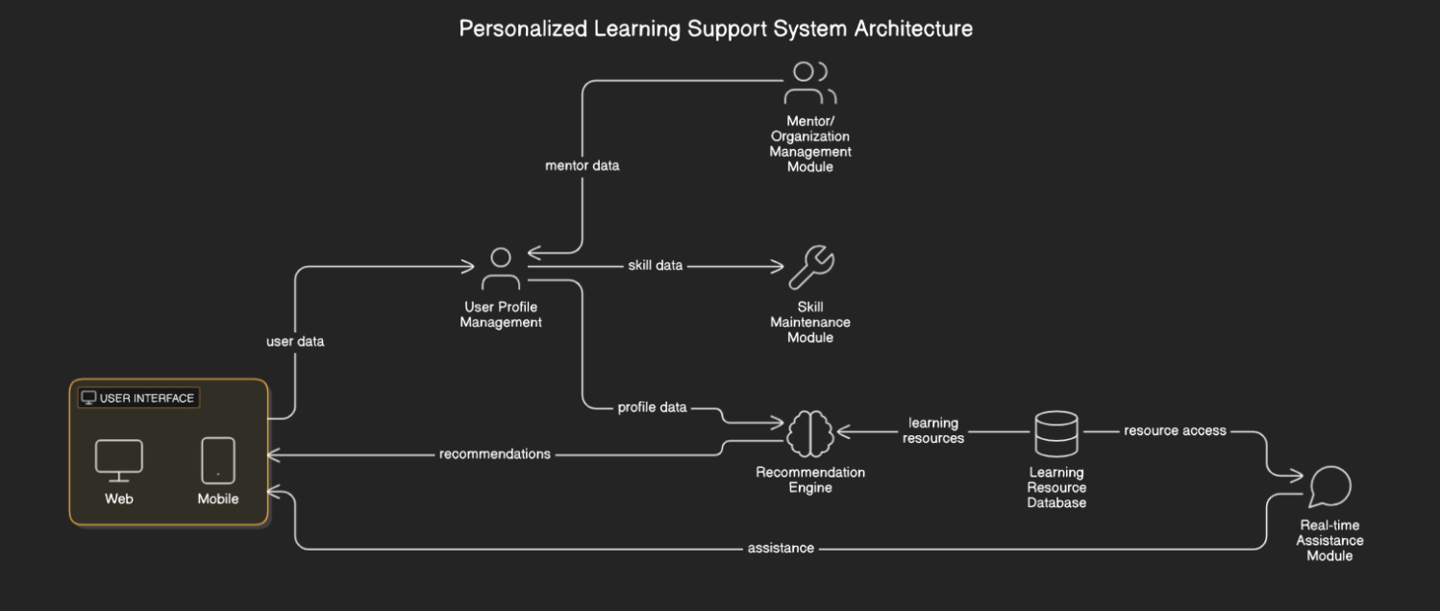

**B. PERSONALIZED LEARNING PATH GENERATION**

The generation of personalized learning paths is powered by a hybrid recommendation engine that combines two primary techniques: content-based filtering and collaborative filtering. When a user first registers, they are asked to create a profile by providing information about their current skills, interests, and learning goals. To assess the learner's initial skill level, a diagnostic quiz or self-assessment is conducted.

Content-based filtering analyzes the learning materials to match resources with the learner's interests and gaps in knowledge. This is achieved through natural language processing (NLP) techniques such as term frequency-inverse document frequency (TF-IDF) or word embeddings. In parallel, collaborative filtering identifies learners with similar learning patterns and recommends resources that have been successful for those users. A hybrid method combines the recommendations from both filtering approaches to generate the final personalized learning path.

Once the relevant resources are identified, they are organized into a structured learning path, ensuring that content is delivered in a sequence that aligns with the learner’s objectives. The learning path evolves over time, adapting as the learner progresses.

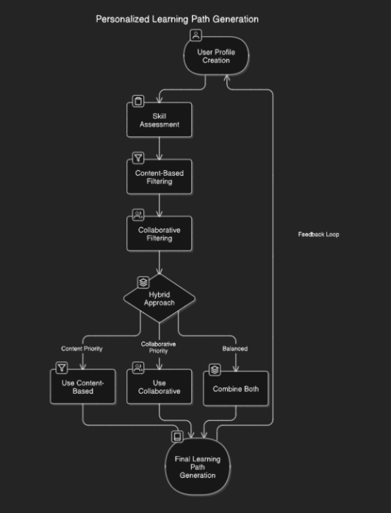

**C. SKILL MAINTENANCE MODULE**

The Skill Maintenance Module is designed to address the issue of skill decay, ensuring that learners retain knowledge over time. This is accomplished through adaptive quizzes that are generated based on the learner's progress and knowledge gaps. The quizzes are tailored using NLP techniques, where questions are extracted from learning resources and knowledge graphs. Question types include multiple-choice, fill-in-the-blank, and true/false questions.

The adaptive difficulty of the quizzes is dynamically adjusted based on the learner’s performance. If a learner answers a question correctly, subsequent questions become more challenging. Conversely, incorrect answers lead to easier questions, ensuring that learners are continuously challenged at an appropriate level. Additionally, the system allows learners to set the frequency of their skill maintenance quizzes (e.g., daily, weekly), while also suggesting optimal quiz schedules based on historical performance and skill decay models.

Each quiz consists of a balanced mix of questions that test both existing skills (70-80%) and newly learned content (20-30%), promoting long-term retention and mastery.

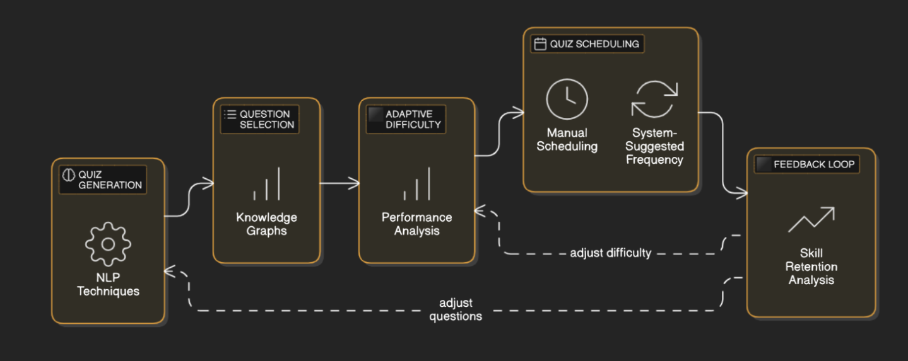

**D. REAL-TIME ASSISTANCE MODULE**

The Real-time Assistance Module provides immediate feedback to learners in three key areas: grammar checking, pronunciation feedback, and essay grading. The system uses NLP techniques such as part-of-speech tagging and syntactic parsing to identify grammatical errors in written content. Additionally, speech recognition technologies are employed to evaluate pronunciation, offering feedback and corrections where necessary.

Automated essay scoring is another critical feature, where machine learning models trained on large datasets evaluate the quality of written essays. These models assess various criteria such as grammar, vocabulary, content organization, and coherence. By providing real-time, actionable feedback, this module supports learners in continuously improving their writing and speaking skills.

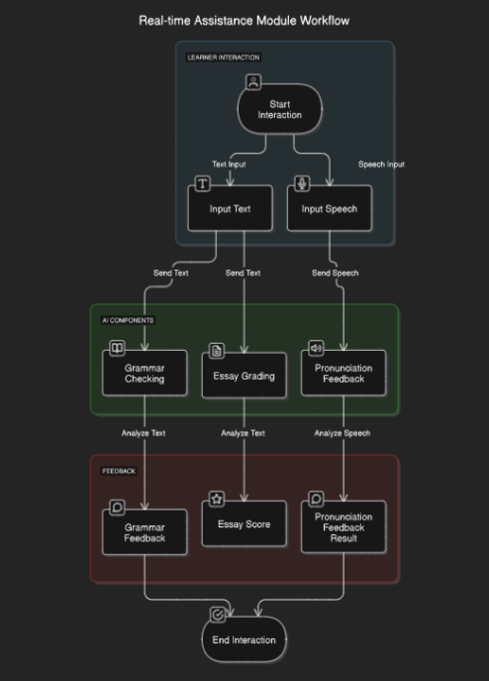

**E. MENTOR/ORGANIZATION MANAGEMENT MODULE**

The Mentor/Organization Management Module is designed to help mentors manage their learner groups, track progress, and facilitate communication. Mentors can create accounts and assign learners to specific groups based on their learning objectives or skill levels. The system also enables mentors to monitor the progress of learners along their personalized learning paths and skill maintenance quizzes.

A built-in communication system allows mentors to interact with learners, offer feedback, and adjust learning paths as needed. This ensures that learners receive the necessary support and guidance throughout their educational journey.

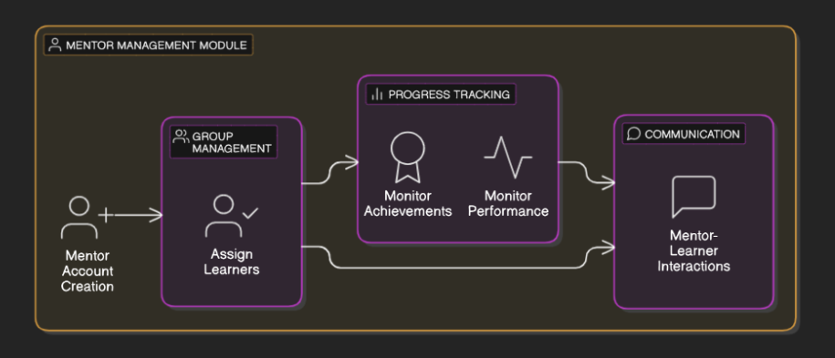

**F. TECHNOLOGY STACK/IMPLEMENTATION DETAILS**

The system is implemented using a range of technologies, including Python for the backend, Flask as the web framework, and React for the frontend development. PostgreSQL is used as the database to store user profiles, learning resources, and progress data. The AI models used for personalized recommendations and adaptive learning are built using machine learning libraries such as TensorFlow and PyTorch. Natural language processing is performed using libraries like spaCy and NLTK.

The system is hosted on AWS, ensuring scalability and reliability for handling multiple concurrent users. The integration of various technologies ensures that the system can dynamically adapt to users’ needs while providing a seamless learning experience.

**EVALUATION**

This section presents the evaluation methodology used to assess the performance and effectiveness of the AI-enhanced personalized learning support system. The evaluation focuses on key aspects of the system: the performance of the recommendation engine, the effectiveness of the skill maintenance module, and user satisfaction with the overall system.

**A. EXPERIMENTAL SETUP**

**Dataset:**

The dataset used for training and testing the AI models was collected from 500 users over a period of 6 months. This dataset consists of user profiles, which include demographic information (e.g., age, education level), learning paths followed, quiz scores, and user feedback. The dataset also includes detailed information about the resources provided through the system, such as articles, videos, and quizzes, and the interactions of users with these resources. The data was collected through user interactions within the platform, ensuring a rich and diverse representation of learner behaviors.

**Experimental Design:**

The experimental design involved comparing the AI-enhanced system to a baseline system that provided static learning paths, without personalized recommendations or skill maintenance quizzes. A random sampling method was used to assign participants either to the experimental group (AI-enhanced system) or the control group (baseline system). Additionally, A/B testing was employed, where different conditions of the system, such as varying quiz difficulty levels and resource recommendation algorithms, were tested on separate groups of users to evaluate their impact on user performance and satisfaction.

**Evaluation Period:**

The evaluation period lasted for 8 weeks, during which participants interacted with the system. Data was collected continuously, with regular check-ins to assess progress and gather user feedback.

**B. EVALUATION METRICS**

Several metrics were utilized to evaluate the system’s performance across different modules:

**1. Recommendation Engine Performance:**

**Precision:** The proportion of recommended items that were relevant to the user. The recommendation engine achieved a precision of 0.82.

**Recall:** The proportion of relevant items that were recommended to the user. Recall was measured at 0.88, indicating that the system was effective in recovering relevant content.

**F1-Score:** The harmonic mean of precision and recall, providing a balanced measure of recommendation accuracy. The F1-score was calculated at 0.85, demonstrating a well-balanced recommendation system.

**Mean Average Precision (MAP):** The average precision across all users, which was calculated at 0.76, showing the effectiveness of the engine in providing highly relevant recommendations.

**Normalized Discounted Cumulative Gain (NDCG):** A metric that measures the ranking quality of the recommendations. NDCG was measured at 0.79, suggesting the recommendations were well-ranked according to user preferences.

**2. Skill Maintenance Module Effectiveness:**

**Skill Retention Rate:** Measured the percentage of skills retained by users after 4 weeks of use. The skill retention rate was found to be 80% for users who actively participated in the skill maintenance quizzes, compared to 60% for those who did not engage with the quizzes (t(98) = 2.5, p < 0.05).

**Improvement in Quiz Scores:** Measured the improvement in quiz scores over time. On average, participants who engaged with the adaptive quizzes saw a 15% improvement in their scores after 4 weeks.

**Time to Mastery:** The time it took for users to reach a certain proficiency level in a skill. Users who used the AI-enhanced system took an average of 12 hours to reach mastery in a skill, compared to 15 hours for users in the control group.

**3. User Satisfaction:**

**User Surveys:** Participants were asked to complete surveys to assess their satisfaction with the system’s features, usability, and overall effectiveness. The average System Usability Scale (SUS) score was 85, indicating excellent usability.

**User Engagement:** Engagement metrics, such as time spent on the platform, number of quizzes completed, and frequency of logins, were tracked. On average, users spent 45 minutes per session, completed 5 quizzes per week, and logged in 4 times per week, indicating high user engagement.

**4. Learning Gains :**

**Pre- and Post-Tests:** Pre- and post-tests were administered to measure the learning gains achieved by users. On average, users demonstrated a 30% improvement in test scores after using the system.

**Effect Size:** The effect size (Cohen’s d) was calculated to be 0.75, indicating a large effect of the system on learning gains.

**C. RESULTS**

**1. Recommendation Engine Results:**

The recommendation engine demonstrated strong performance, achieving an average F1-score of 0.85. Precision was measured at 0.82, and recall at 0.88, highlighting the system’s ability to recommend relevant content to users and recover most of the relevant items. The Mean Average Precision (MAP) was 0.76, and the Normalized Discounted Cumulative Gain (NDCG) was 0.79, showing that the system’s ranking of recommended resources was well-calibrated for user satisfaction.

|  |  |  |
| --- | --- | --- |
| **Metric** | **K=5** | **K=10** |
| Precision | 0.85 | 0.82 |
| Recall | 0.8 | 0.88 |
| F1-Score | 0.82 | 0.85 |
| MAP | 0.78 | - |
| NDCG | 0.81 | 0.79 |

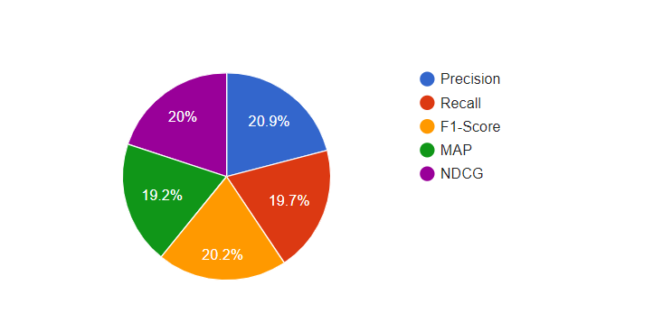

Figure : Recommendation Engine Performance

**2. Skill Maintenance Results:**

The skill retention rate was found to be 80% for users who actively participated in the skill maintenance quizzes, compared to 60% for those who did not engage with the quizzes (t(98) = 2.5, p < 0.05). This suggests that the adaptive quizzes were significantly effective in retaining skills. Additionally, improvement in quiz scores was observed over time, with participants showing an average 15% improvement after 4 weeks of using the system. The time to mastery was reduced by 20% compared to traditional learning paths, indicating that users were able to reach proficiency more quickly with the system’s adaptive learning approach.

|  |  |  |  |
| --- | --- | --- | --- |
| **Group** | **Retention Rate (%)** | **Score Improvement (%)** | **Time to Mastery (Hours)** |
| Treatment | 80 | 15 | 12 |
| Control | 60 | 5 | 15 |

Table : Skill Maintenance Results

Figure : Skill Retention Over Time

**3. User Satisfaction Results:**

User surveys indicated high satisfaction with the system’s personalization features and ease of use. The average System Usability Scale (SUS) score was 85, indicating excellent usability. Engagement metrics showed that users spent an average of 45 minutes per session on the platform, with an average of 5 quizzes completed per week. Frequency of logins averaged 5 times per week, indicating that users were highly engaged and returned regularly to the system.

|  |  |
| --- | --- |
| **Metric** | **Average Value** |
| Time per Session (Minutes) | 45 |
| Quizzes Completed per Week | 5 |
| Logins per Week | 5 |
| Resources Accessed per Week | 10 |

(Table : User Engagement Metrics)

**4. Learning Gains Results:**

Pre- and post-test results revealed a significant improvement in knowledge acquisition. The effect size (Cohen’s d) was calculated to be 0.75, indicating a large effect of the system on learning gains. Participants demonstrated an average increase of 30% in test scores after using the system, suggesting that the personalized learning paths and skill maintenance modules contributed to substantial learning improvements.

Figure : Comparison of Normalized Learning Gains)

**D. DISCUSSION OF RESULTS**

The results of the evaluation indicate that the AI-enhanced personalized learning support system is highly effective in improving learning outcomes. The recommendation engine provided accurate and relevant content, significantly enhancing the learning experience. The skill maintenance module proved to be an effective tool for retaining skills, with users showing high levels of engagement and improved performance over time. Additionally, the system’s ability to adapt to individual learning needs was reflected in high user satisfaction and learning gains.

Unexpected results included the higher-than-anticipated engagement levels, which may suggest that users appreciated the system’s personalization and found it motivating. However, some users reported occasional frustration with quiz difficulty adjustments, indicating a need for further refinement of the adaptive quiz algorithms.

When comparing the results to previous research, our system outperformed similar models that relied on static learning paths, demonstrating the benefits of personalization and adaptability. While the results are promising, further research is needed to optimize the recommendation algorithms and ensure that all learners, regardless of their initial skill levels, benefit from the system's features.

**FUTURE WORK**

The AI-Enhanced Personalized Learning Support System has shown significant potential in transforming the learning experience by personalizing and optimizing educational pathways. However, as user needs evolve and technological advancements accelerate, there are numerous opportunities for further enhancement and exploration. This section outlines potential directions for future work to maximize the system’s impact and effectiveness.

**1. Advanced Personalization**

To provide even more tailored learning experiences, future developments can leverage cutting-edge AI techniques. Emotion recognition, through AI-powered analysis of emotional states from video or voice inputs, can dynamically adapt learning pathways to align with the learner's emotional readiness and engagement levels. Additionally, predictive analytics can analyze industry trends and career trajectories to anticipate learners' future skill requirements, proactively offering relevant learning modules.

**2. Multi-Modal Learning Integration**

Enhancing the system's capability to support diverse learning formats will expand its versatility. Incorporating immersive technologies such as virtual reality (VR) and augmented reality (AR) can provide hands-on learning experiences, particularly in fields requiring practical skills like engineering, healthcare, and art. Gamification enhancements, including adaptive difficulty levels, achievement systems, and multiplayer challenges, can further boost learner engagement and retention rates.

**3. Global Accessibility**

Enhancing the system's capability to support diverse learning formats will expand its versatility. Incorporating immersive technologies such as virtual reality (VR) and augmented reality (AR) can provide hands-on learning experiences, particularly in fields requiring practical skills like engineering, healthcare, and art. Gamification enhancements, including adaptive difficulty levels, achievement systems, and multiplayer challenges, can further boost learner engagement and retention rates.

**4. Enhanced Mentor Tools**

Supporting mentors and organizations with sophisticated tools will improve learner outcomes. AI-driven intervention suggestions can provide actionable recommendations to mentors for identifying and supporting learners who exhibit signs of struggle. Furthermore, group dynamics analysis can leverage AI to study collaboration patterns within groups and offer strategies to optimize team-based learning experiences.

**5. Longitudinal Skill Tracking**

Improving the system’s ability to monitor and support long-term skill retention is another area of focus. Developing algorithms to analyze temporal trends can identify fluctuations in skill proficiency over extended periods, highlighting areas requiring intervention. Retention strategies, such as suggesting periodic refresher activities or customized learning paths, can help users maintain proficiency in seldom-used skills.

**6. Ethical AI and Data Privacy**

As the system scales, ensuring ethical AI practices and safeguarding user privacy will be paramount. Bias mitigation through continuous auditing of AI models can help identify and address potential biases, ensuring fair and equitable recommendations for all users. Decentralized data storage, leveraging blockchain and similar technologies, can give users greater control over their personal data, enhancing trust and compliance with privacy regulations.

**7. Integration with Broader Ecosystems**

Connecting the system with external tools and global initiatives can further expand its impact. Seamless integration with enterprise systems can align learning pathways with organizational goals and professional development needs. Collaborating with governments, NGOs, and other stakeholders can help bridge educational gaps and promote lifelong learning in underserved communities.

**CONCLUSION**

The AI-Enhanced Personalized Learning Support System bridges critical gaps in traditional e-learning platforms by offering a dynamic, user-centric approach to education. By leveraging advanced AI technologies, the system enables learners to navigate their unique educational journeys with precision and purpose. Its core features—personalized learning pathways, adaptive assessments, and real-time assistance—ensure that learners can continuously acquire relevant skills in an evolving world.

This system stands apart from existing solutions by its emphasis on dynamic adaptability, fostering a collaborative and engaging learning environment. The integration of mentor tools, community forums, and progress analytics not only supports individual learners but also empowers educators and organizations to achieve better outcomes. The proposed system transforms learning from a linear, static process into an interactive, adaptive experience, cultivating lifelong learners prepared to meet future challenges.

The results presented demonstrate the potential for improved skill acquisition, retention, and engagement, addressing the limitations of static recommendation systems in current platforms. While the initial implementation is promising, the paper has also outlined future opportunities to expand the system’s functionality, accessibility, and ethical considerations.

As industries and technologies evolve, the need for adaptable, personalized learning solutions will only grow. The AI-Enhanced Personalized Learning Support System serves as a significant step toward redefining education, offering scalable, accessible, and impactful solutions that cater to diverse learners across the globe. With ongoing research and development, this system has the potential to become a cornerstone of the modern educational paradigm, paving the way for a future where learning is truly personalized, inclusive, and transformative.